**20. Create a SQL storage service and perform a basic query using any Public Cloud Service Provider (Azure/GCP/AWS) to demonstrate Database as a Service (DaaS).**

**STEP1:**

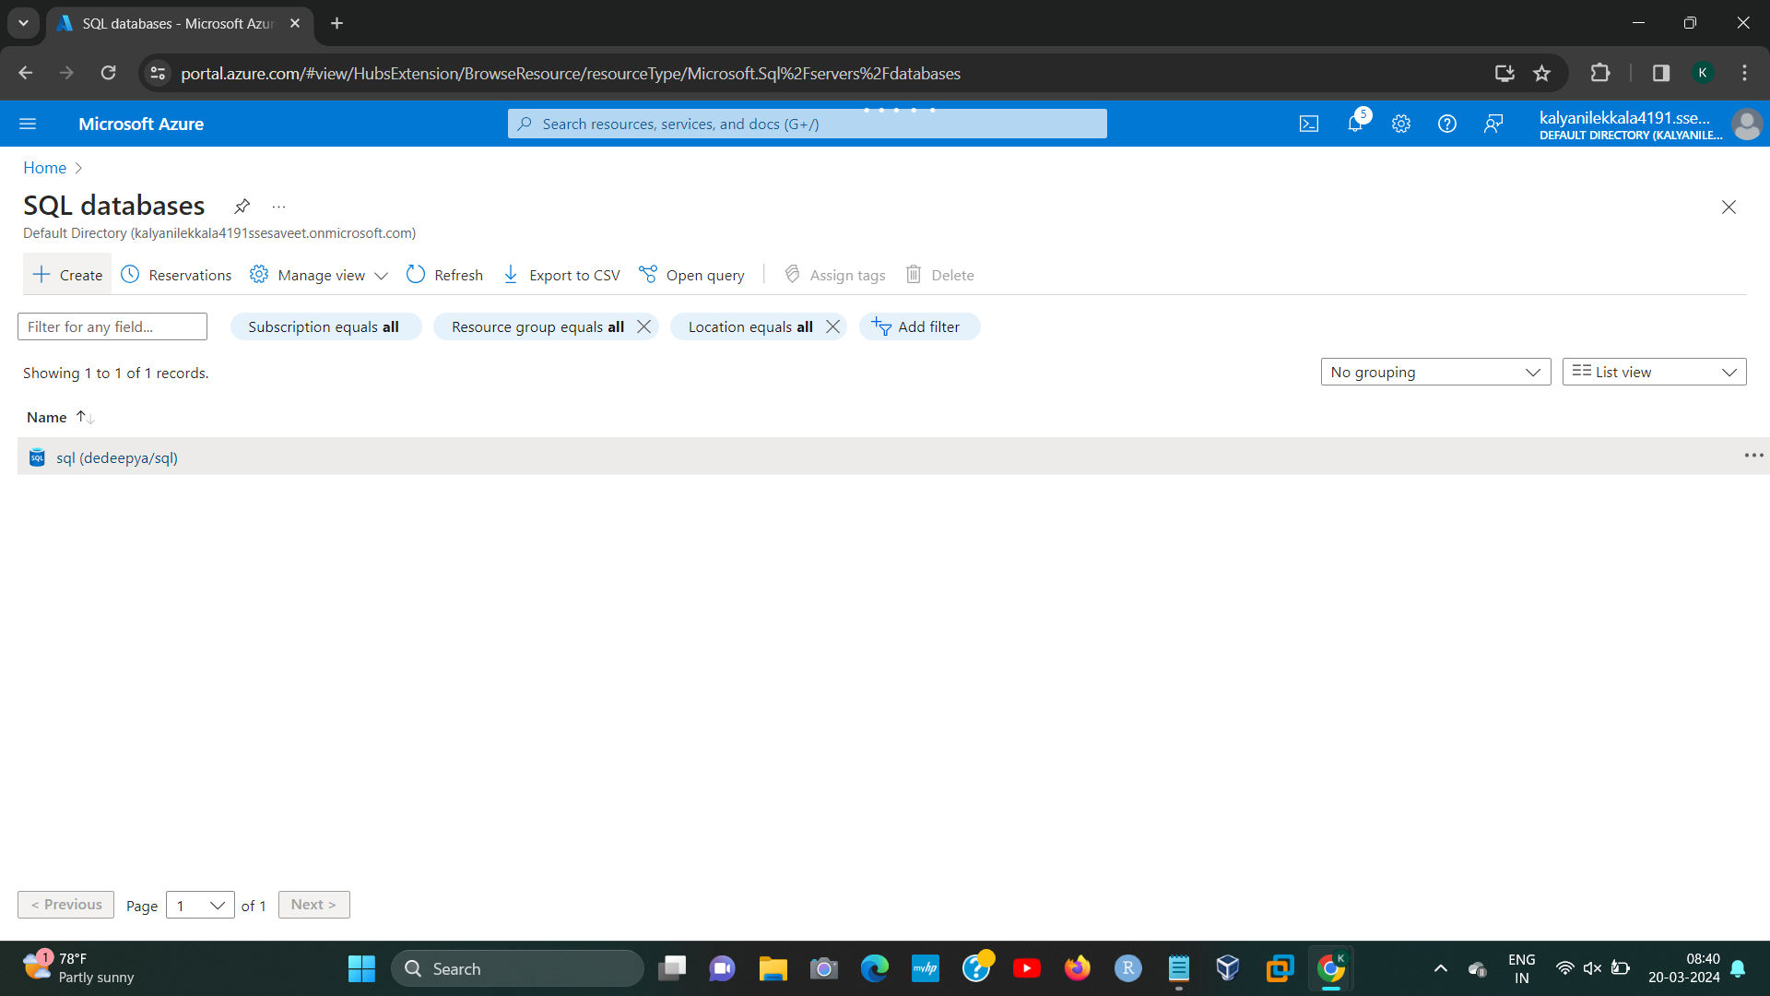

**STEP2:**

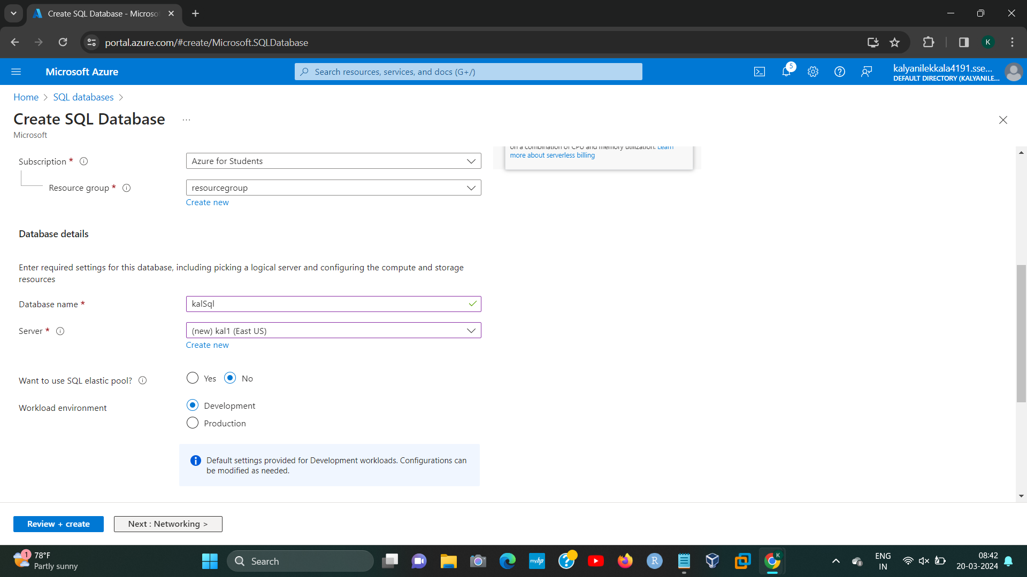**[1]**

**STEP3:**

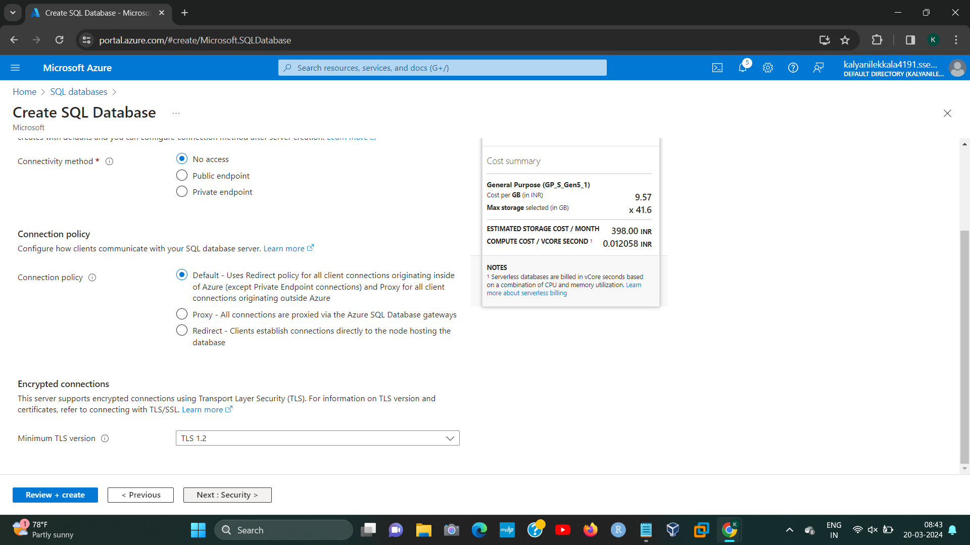

**STEP4:**

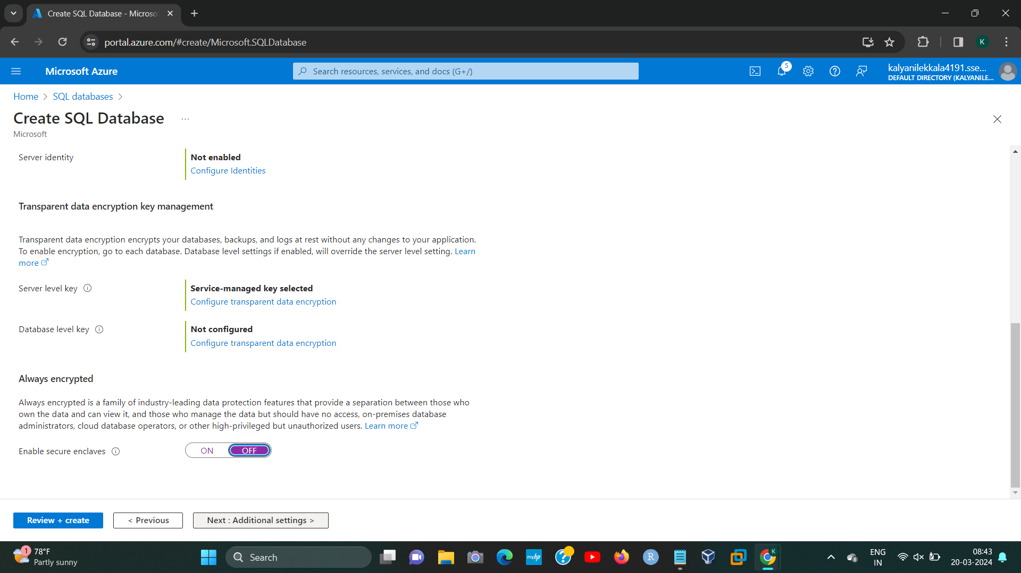

192224191 L.KALYANI

**STEP5:**

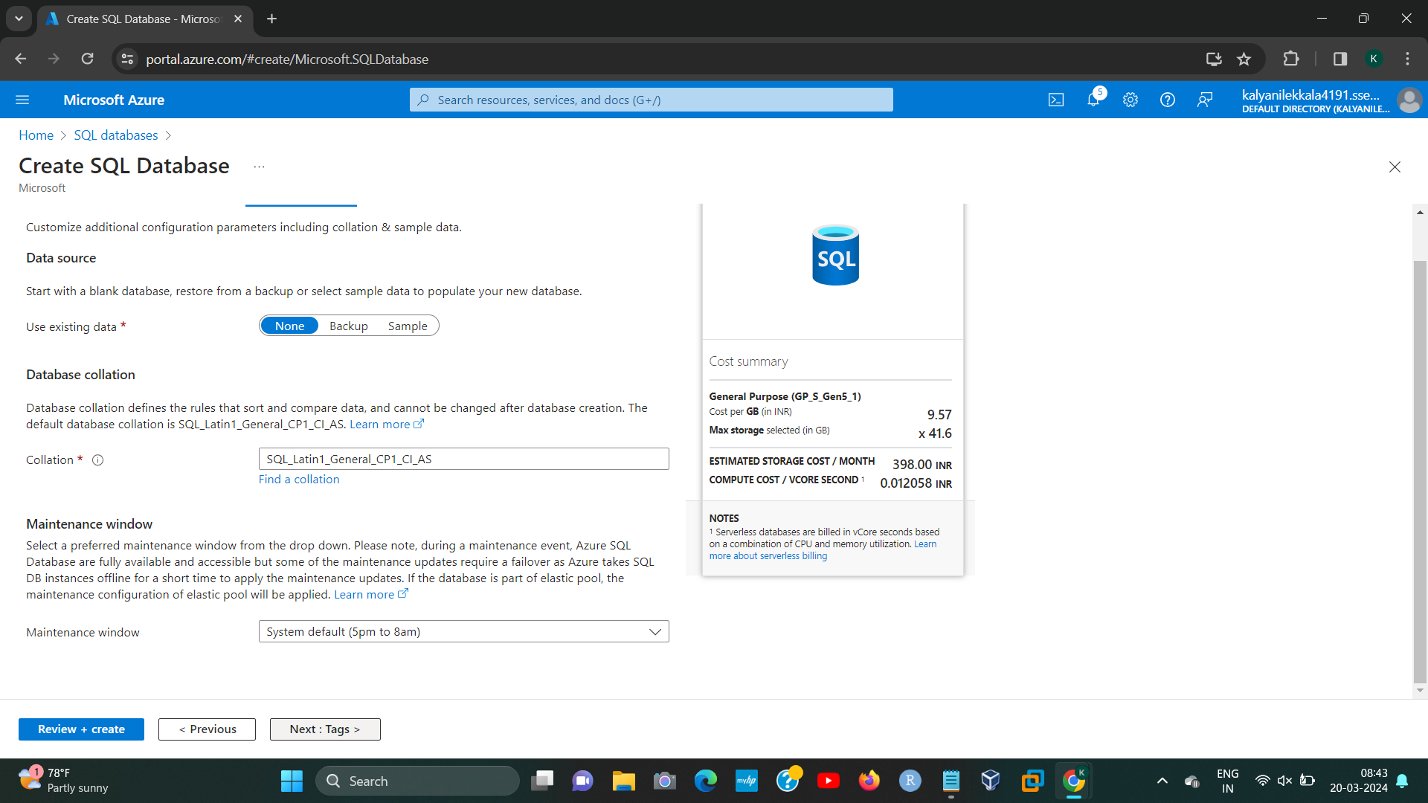

**STEP6:**

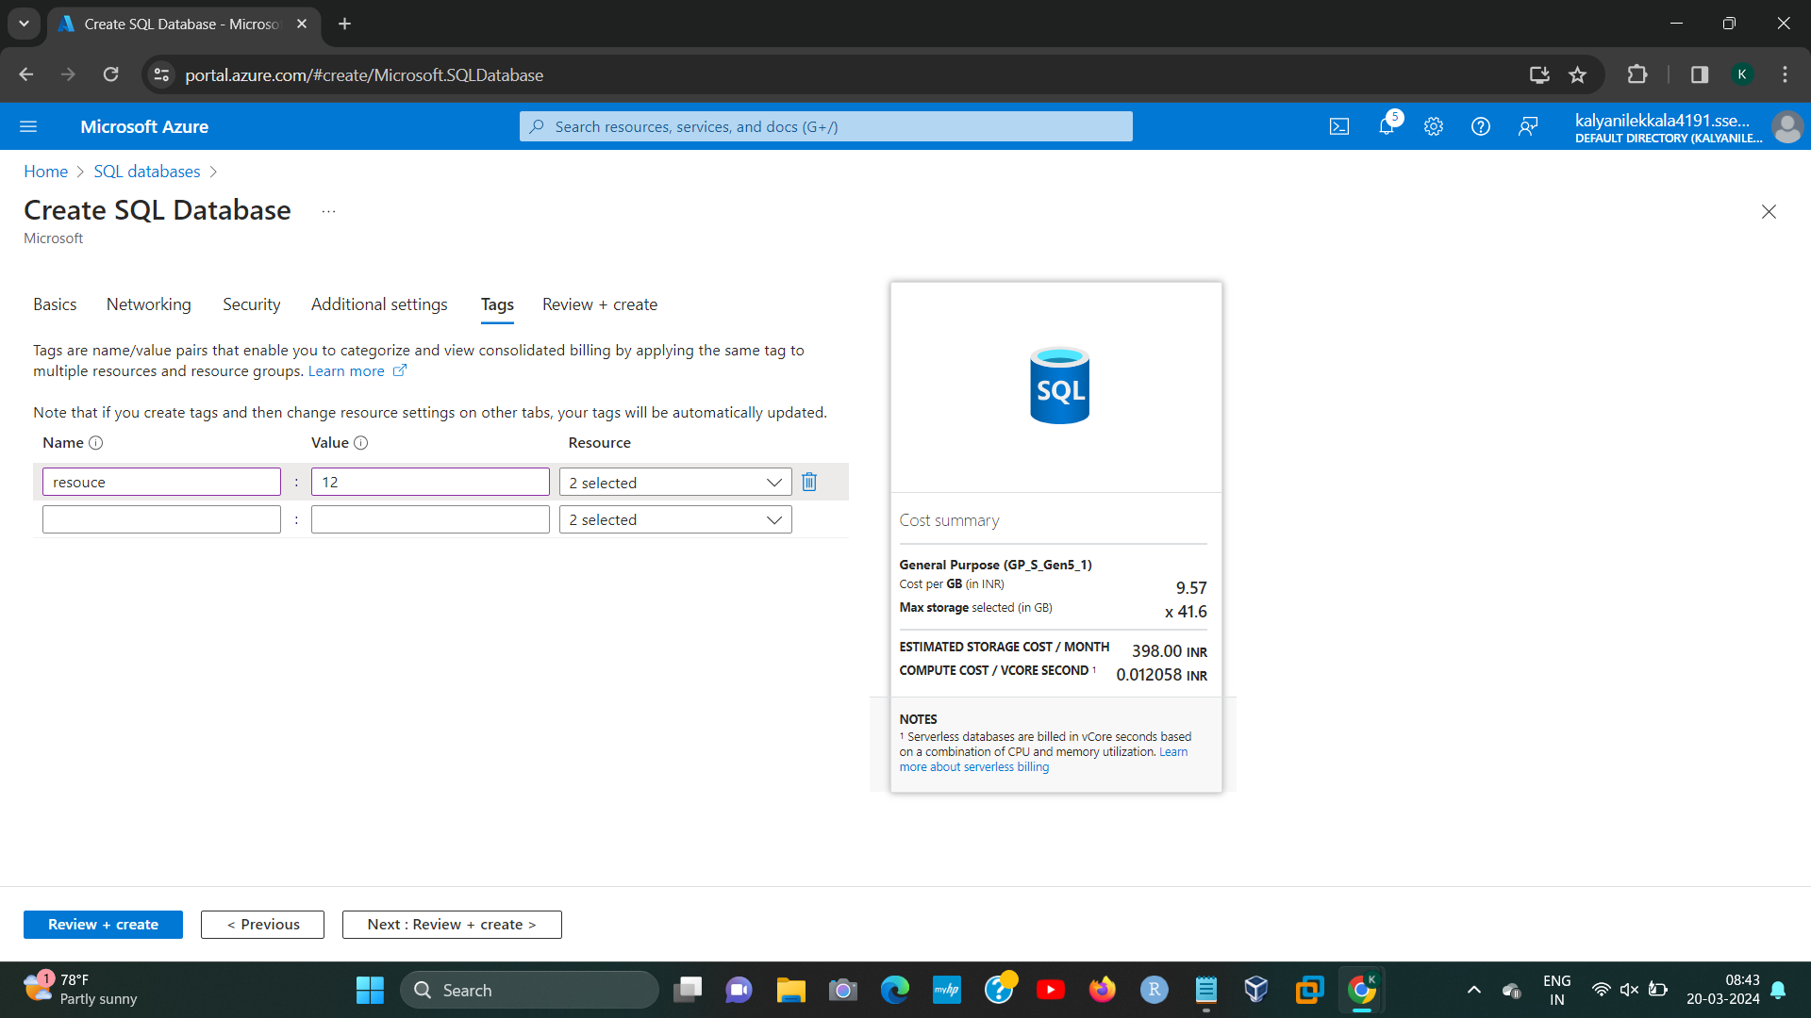

192224191 L.KALYANI

**STEP7:**

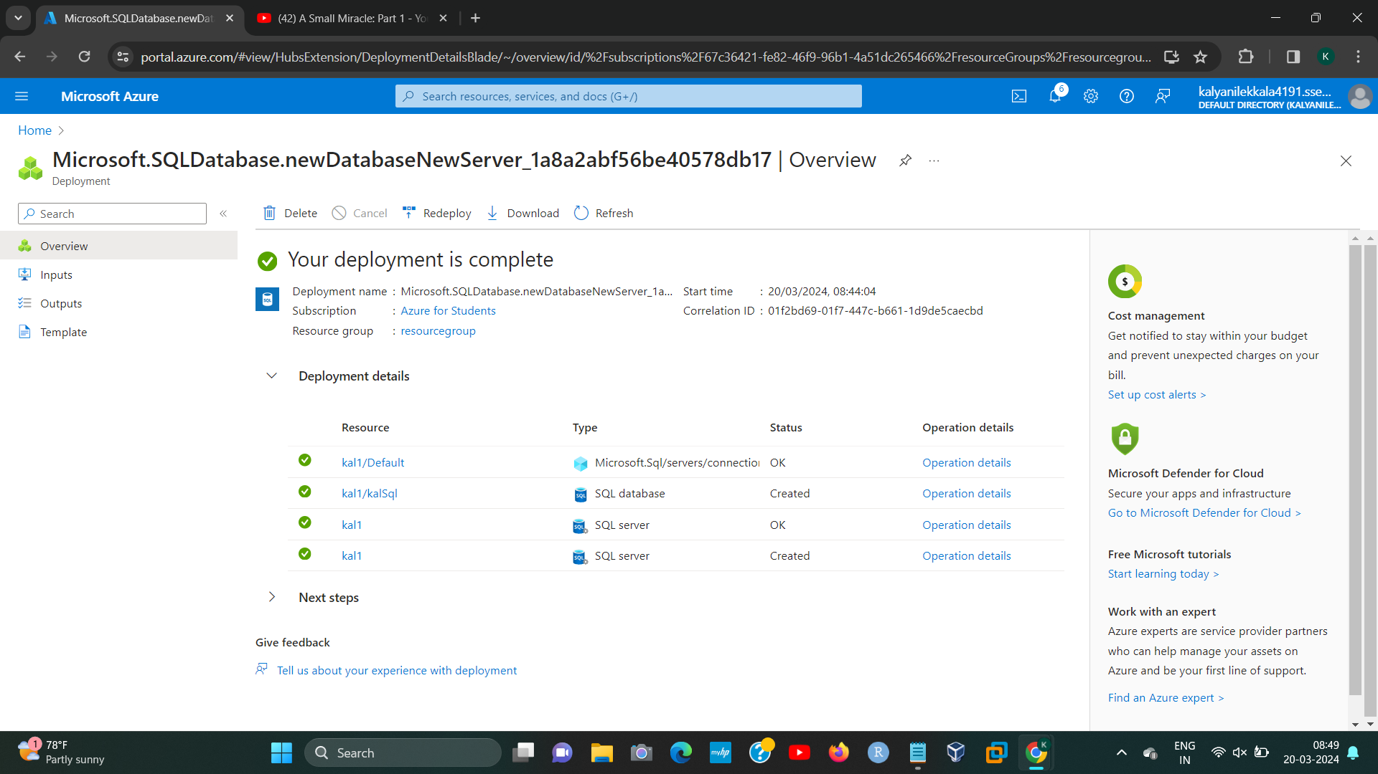

192224191 L.KALYANI

1. 192224191 L.KALYANI